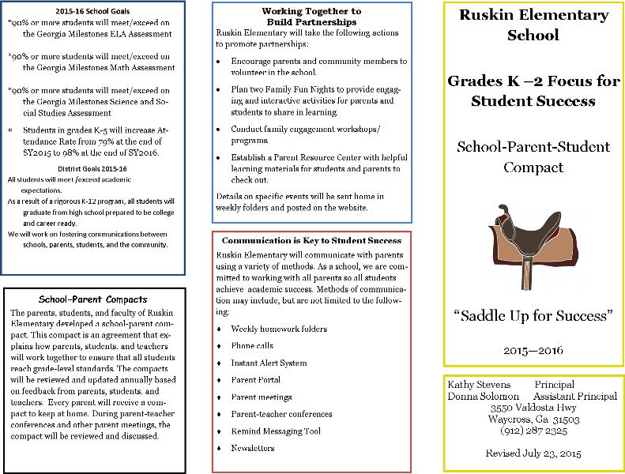

**SCHOOL** **Will**:

Reading

◻ Provide families with a list of sight words for practice at home and monitor frequently at school.

◻ Provide a list of vocabulary words for students to master from fiction and non-fiction texts.

◻ Provide students with appropriate books to increase Lexile levels, comprehension, and reading fluency.

Math

◻ Provide families with free apps and websites to practice math facts at home.

◻ Provide weekly worksheets to complete at home to reinforce basic math facts.

⇒ Provide a daily folder with homework assignments and skills sheets to be practiced at home.

⇒ Conduct programs/workshops in order to share classroom strategies with families to help their child achieve academic success.

⇒ Provide multiple opportunities for families to discuss their child’s academic achievement through conferences, phone calls, and e-mails.

{Math} To provide activities to become fluent with addition and subtraction basic facts and provide application experience of the facts.

To provide reading and math support to students who have not yet mastered grade level skills to close the achievement gap.

To provide meaningful homework that reinforces classroom instruction and provides ways for parents to boost their students’ achievement.

To provide family programs to help parents understand the College and Career-Ready Standards and ways to help students at home .

**PARENTS WILL:**

Reading

◻ Play word games with sight words and new vocabulary words and find ways to use these words in daily conversations.

◻ Practice sight words with my child daily.

◻ Listen to my child read daily to help build their vocabulary.

◻ Listen to my child read orally on a daily basis to increase reading fluency.

Math

◻ Use the apps and websites my child’s teacher provides to practice math facts.

◻ Work with my child weekly to complete math worksheets.

⇒ Check the daily folder for homework and worksheets to make sure my child completes daily homework and studies for weekly tests.

⇒ Participate in workshops to gain knowledge & skills in order to help my child.

⇒ Contact my child’s teacher to discuss my child’s academic achievement either through conferences, phone calls, and/or e-mails.

-to use the weekly folder to review nightly homework, receive notification of upcoming events and as a communication tool with the teacher. Parents are requested to sign the folder each night.

-to read with your student 20 minutes each day. Let them describe the characters, summarize the events of the story in the correct order.

-to increase mathematical fluency in the four basic operations using flashcards, math websites, and practice drills.

-to practice and review until they master basic multiplication facts

-To attend family programs, Back to School Night, and Parent Teacher Conferences to help monitor your child’s progress

**STUDENTS WILL:**

Reading

◻ Practice my sight words and vocabulary words daily.

◻ Read out loud to my parents daily to improve my reading.

◻ Practice my math facts daily using the apps and websites my teacher provided.

◻ Get my parents to check my daily folder for homework and worksheets to make sure my assignments are completed, and I am prepared for my tests.

◻ Talk to my parents about my school day and what I am learning in reading and math.

◻ Bring home newsletters and notices about parent workshops and other school meetings.

•  To ask questions at school when I don’t understand something.

• To do my homework every day and ask for help when I need it.

•  To talk with my family about what I am learning at school.

• To deliver notes and information from school to my family every day.

• To show good behaviors that include being safe, respectful and prepared for school each day.

**Attendance—IT IS IMPORTANT**

For students to be academically successful, they NEED to be at school and on time. It is the goal of Ruskin Elementary to work with parents to ensure that ALL students are present everyday.

We understand that children get sick and emergencies arise. Please contact your child’s teacher and/or school when your child is absent. When your child returns to school, they MUST bring a note signed by the parent explaining why they were absent.